System Design Document

Kyle Gortych

Southern New Hampshire University

CS 255: System Analysis and Design

Professor Joshua Shawkey

December 14, 2025

UML Diagrams

UML Use Case Diagram

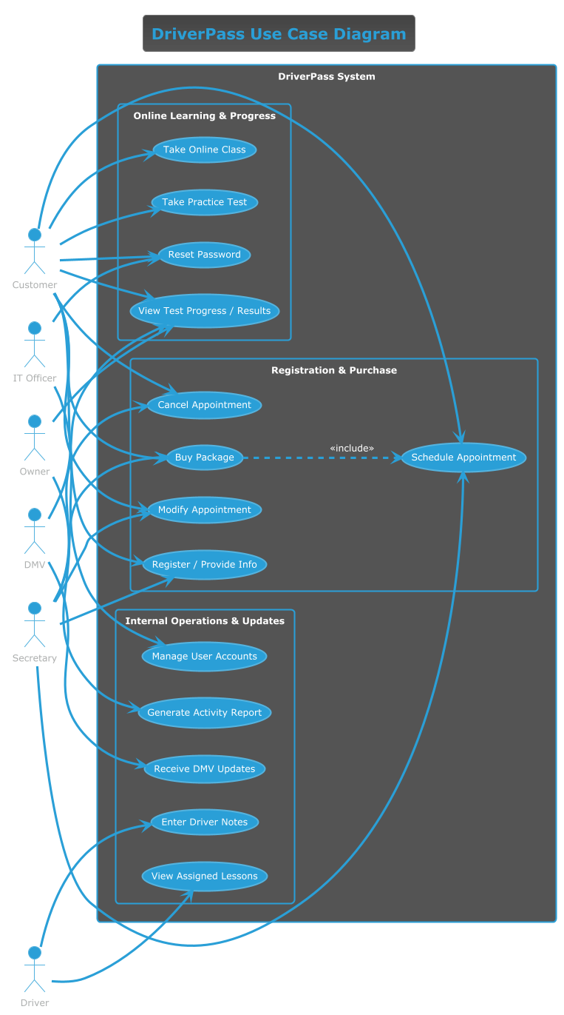

UML Activity Diagrams

Use Case 1 Manage Driving Lesson Reservations:

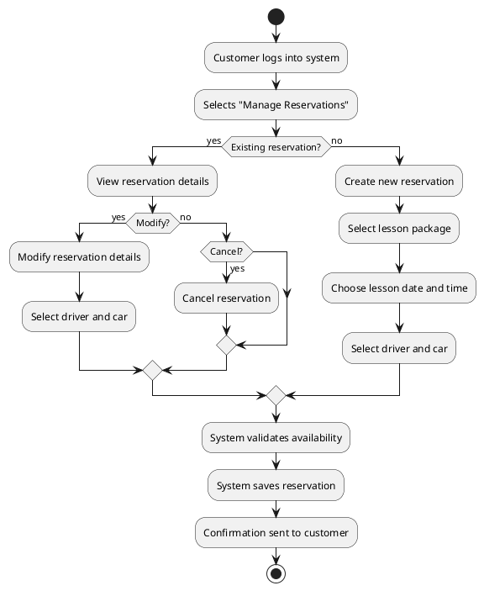

Use Case 2 Customer Registration and Account Management:

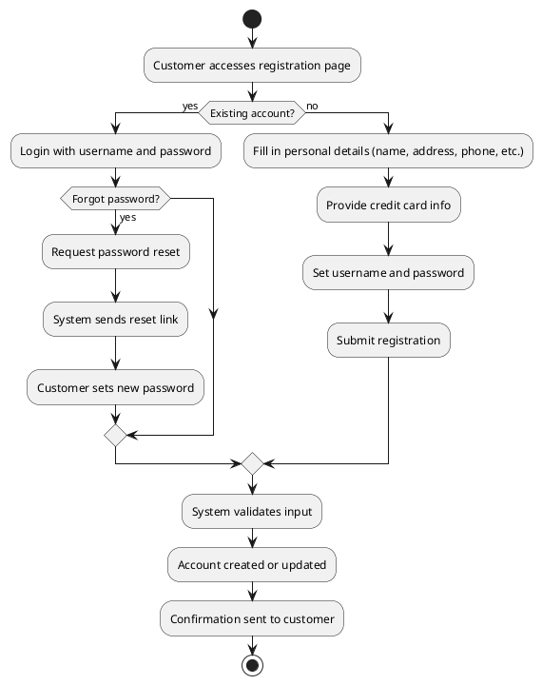

UML Sequence Diagram

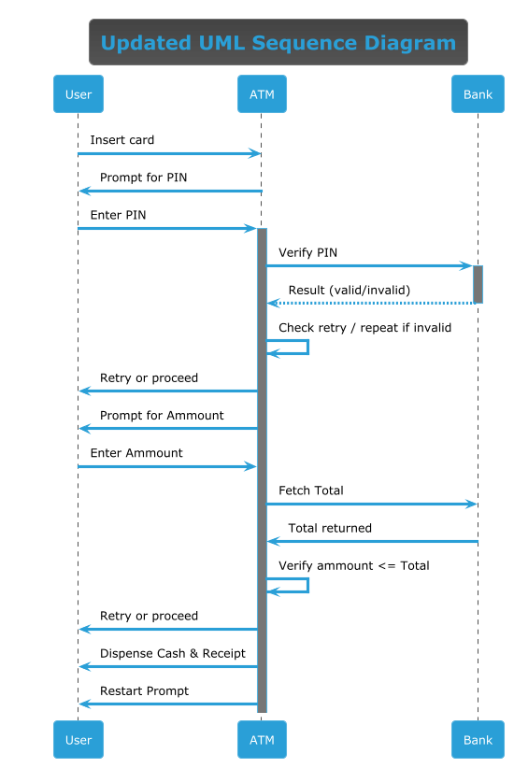

UML Class Diagram

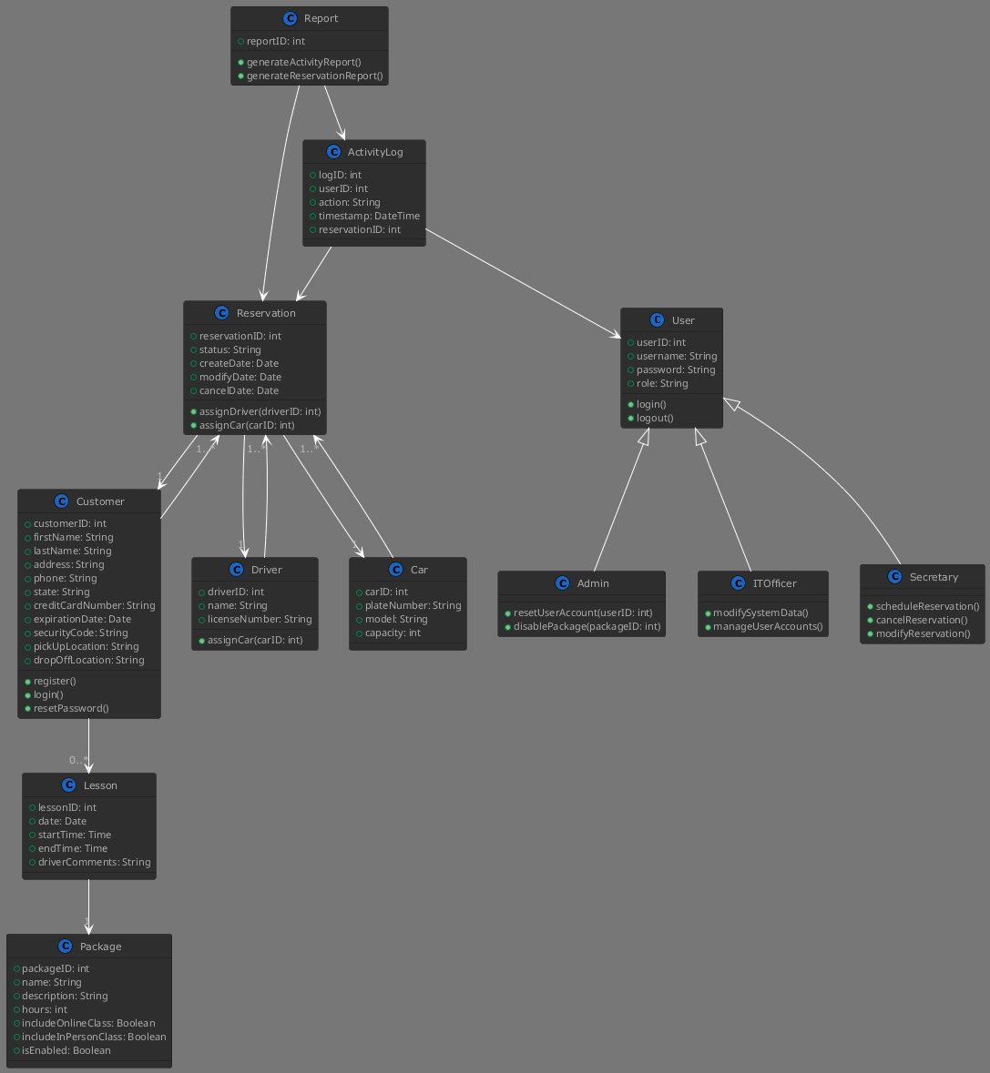

Technical Requirements

The system will require an free and open source LMS that supports the end users, staff, and drivers. An LMS that fits this is Moodle. It provides online classes and practice tests, user accounts with roles and permissions, tracking and reporting, offline access via mobile, and is salable.
The Infrastructure needed for DriverPass system is web server hosting via moodle apache, application runtime via moodle php, database mysql, https and tls possible self signed certificates, and lastly backup and cold storage.
References
MoodleDocs. (2024, June 25). Features. Moodle. https://docs.moodle.org/501/en/Features

